# **Week 12: Heuristic Evaluation**

The goal is to iterate on the prototype enough times within the team before reaching out to your users (next week).

1. Individually: Take at least two passes (first to get a feeling for the flow and scope of the system, then to focus on evaluation). ​Focus on generating as many problems as you can, don’t rank severity yet. ​
2. Combine all problems together (by all team members). ​
3. Individually determine how severe each problem is (from 0–4). ​
4. As a group, discuss and aggregate problems and come to consensus on severity ratings.​ Discuss the changes to be made to the prototype. ​
5. Make the changes and submit an iterated version coming Tuesday (04/26)​

As you can see, you will have to go back and forth between individual work and group work. I want everyone to be involved in evaluating the design.

Tip: take screenshots of your UI and then write a heuristic evaluation for it individually.  
  
**Deliverable:**

List out major heuristic issues that were raised by individuals in the team. This should include three main things:

1. The screenshot of the interface and the accompanying heuristic evaluation.
2. Mention who came up with that problem. Can share multiple names if more than one person mentioned the same issue.
3. Describe the proposed changes, make the changes, and paste the screenshot showing the change.

You should list out **at least** 10 problems (surely, you will find far more than that).

## Severity Ranking Notes

* 0 - Do not agree this is a problem.
* 1 - Usability blemish. Mild annoyance or cosmetic problems. Easily

avoidable.

* 2 - Minor usability problem. Annoying, misleading, unclear,

confusing. Can be avoided or easily learned. May occur only once.

* 3 - Major usability problem. Prevents users from completing tasks.

Highly confusing or unclear. Difficult to avoid. Likely to occur more

than once.

* 4 - Critical usability problem. Users will not be able to accomplish

their goals. Users may quit using the system altogether.

## Heuristic Ranking Notes

1. Visibility of system status

2. Match between system and the real world

3. User control and freedom

4. Consistency and standards

5. Error prevention

6. Recognition rather than recall

7. Flexibility and efficiency of use

8. Aesthetic and minimalist design

9. Help recognize, diagnose, and recover from errors

10. Help and documentation

For the first part, refer to the example below:

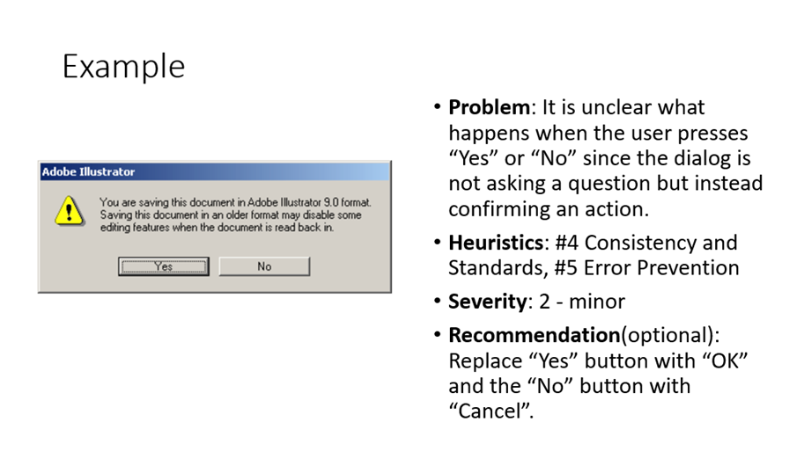

# Individual Evaluations Below:

## Evaluator: William

* **Back button** in the **explore posts page** will go back to the **previous action** rather than the previous page.
  + New post, X to the posts page
  + Back button -> New post
* Redundant Joined tabs/filter on homepage. Categories tab on the left unclear label.
  + 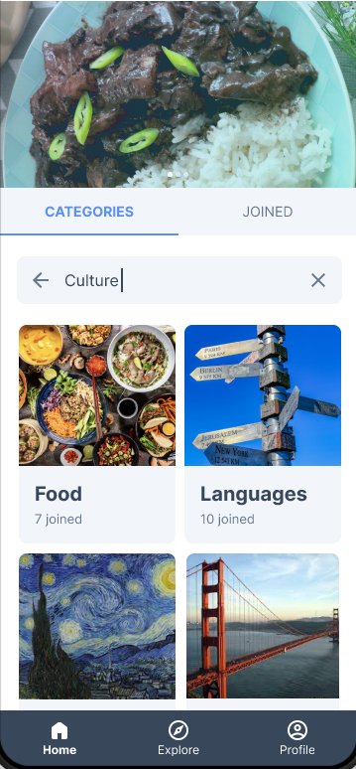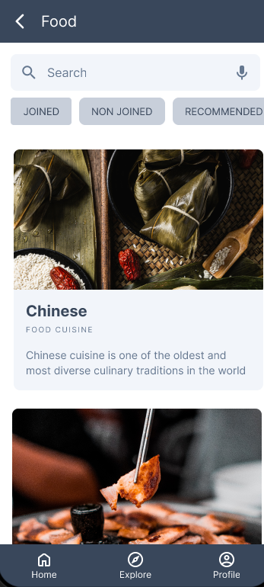
* Make events the 2nd tab consistently.
* Profile nav button is highlighted in explore events tab
  + 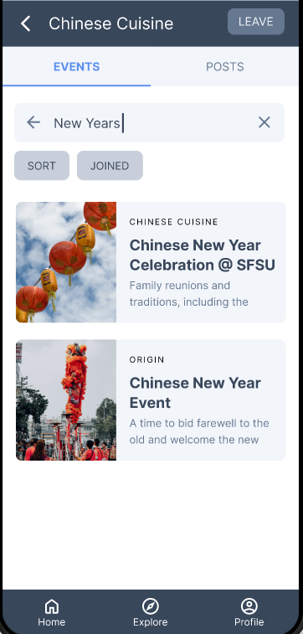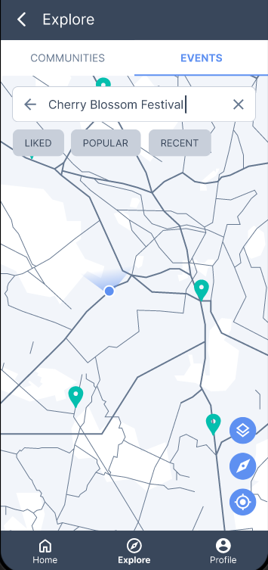

## Evaluator: Leilah

**Problem:** Unable to identify if a community has been joined by the user or not.

Heuristic #1

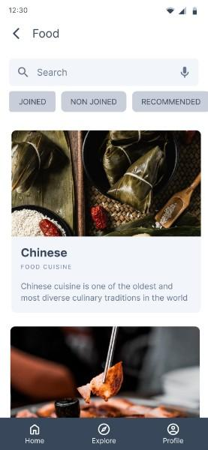

**Problem:** Categories and communities are easily confused with inconsistent naming

Heuristic #6, #4

****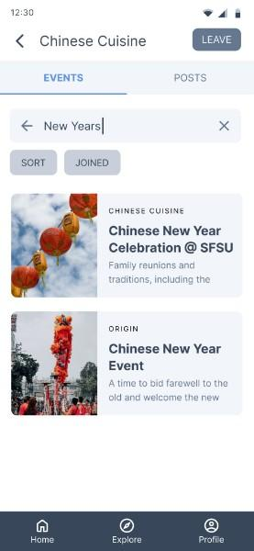

**Problem:** Action bars aren’t explicit enough and can confuse user in navigating the app.

Heuristic #6

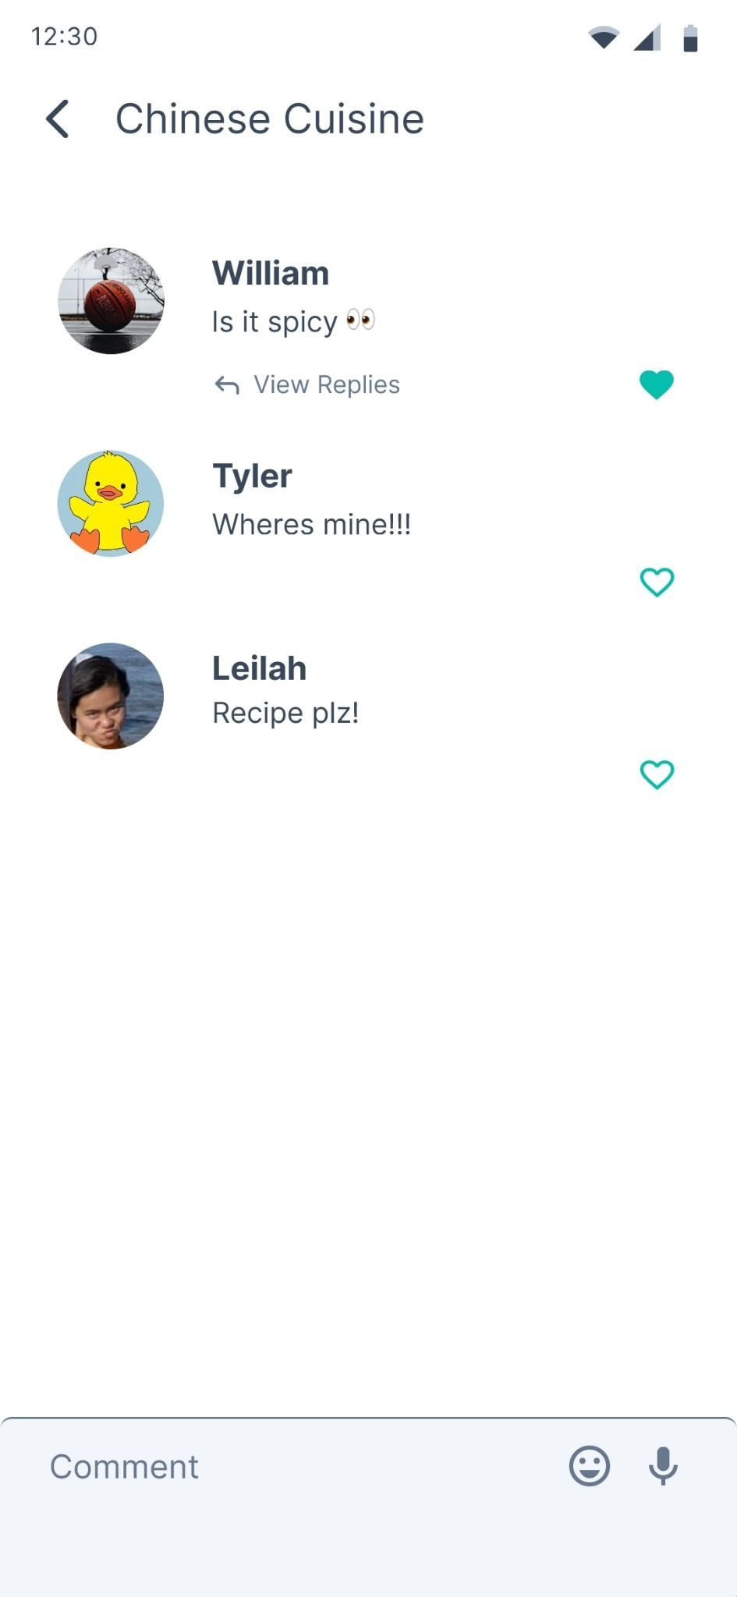

**Problem:** Unfitting search filters in the Explore/Communities page.

Heuristic #2?

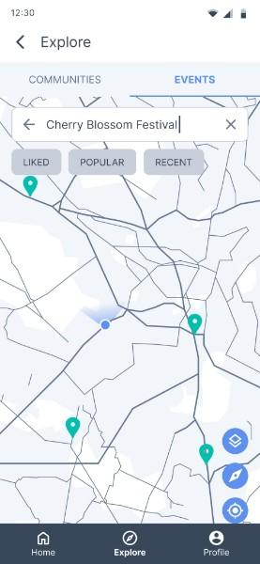

**Problem:** Repetitive naming/information.

Heuristic #7

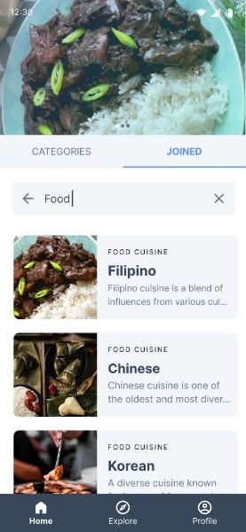

**Problem:** There isn’t a way to delete/remove a post or unjoin a specific event.

Heuristic #3

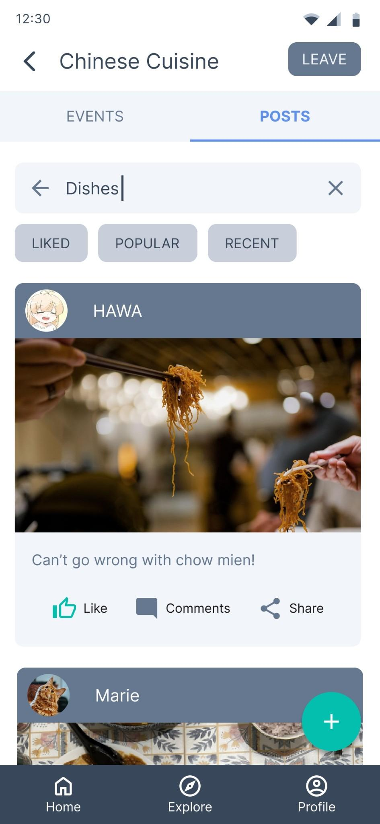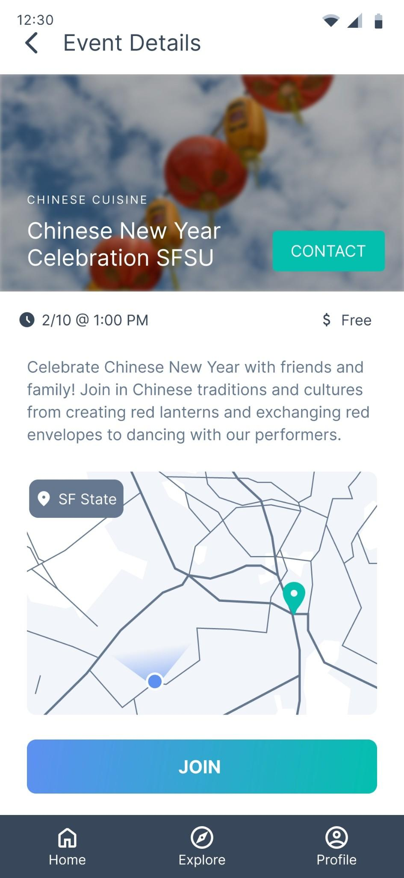

**Problem:** User has no way to go back in the onboarding process and is unaware of progress/status in user onboarding flow.

Heuristic #1, #3

## Evaluator: Marie

**Problem**: There’s a skip button for on-boarding but there is no prototype for a page if user clicks skip

**Problem**: Maybe add a scroll bar for “join first community” page? Does not look like it’s continuous

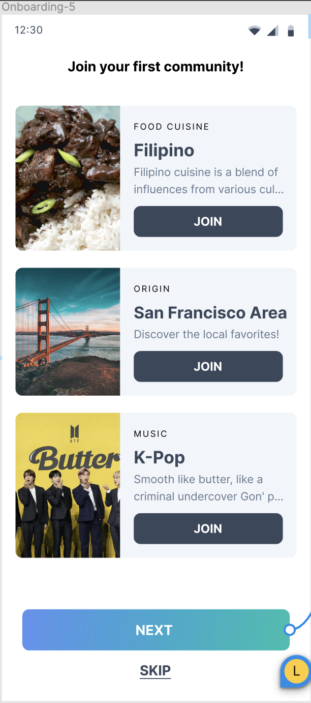

**Problem**: Categories(?)**Problem**: On-boarding 5 (what if the user is interested in non of the community we suggested?)

**Problem**: What if the user wants to bookmark events or how to express RSVP ?

## Evaluator: Tyler

**Problem**: It is unclear what the checkmark and black cross do, it doesn’t clearly explain that the user needs to swipe and will be able to go to the next card available after swiping

Heuristics: #1 Visibility of System Status & #10 Help and Documentation

**Problem**: It is unclear what the purpose of Interests in your onboarding and profile screens do, how do they relate to finding different categories. Where does the system take into account your interest, when viewing different unjoined communities? In the explore page?

Heuristics: #4 Consistency and Standards & #10 Help and Documentation

**Problem**: I am unable to delete a post or comment that I had previously created. Will I be able to go back? There is no undo button for making a comment or post, so if I mess up there is no way for me to change that.

Heuristics: #3 User Control and Freedom & #5 Error Prevention #9 Help recognize, diagnose, and recover from errors

**Problem**: What's the point of signing in? How are you able to convey to the user that you are signed in? What does it show for someone signed in vs having another account? Do I have to go all the way back to profile just to add interests?

Heuristics: #1 Visibility of System Status & #3 User Control and Freedom

**Problem**: Make join/leave button more clear, kinda hard to find how to leave and join different communities, is in a hard place to find

Heuristics: #8 Aesthetic and Minimalist Design & #1 Visibility of System Status & #4 Consistency and Standards

## Evaluator: Andre

**Problem**: Navbar colors is hard to see, it is to see what page you are on

Heuristics: #8 Aesthetic and Minimalist Design & #1 Visibility of System Status & #4 Consistency and Standards

# Final Heuristic Evaluations Below:

**1. Problem**: Community Categories and individual communities are ambiguous and easily confused with inconsistent naming

Heuristics: #6 Recognition rather than recall, #4 Consistency and Standards

Severity: 2

Recommendations:

* Reorganize information architecture and have a separate page for joined communities.
* Ditch the tab UI that organizes “Categories” and “Joined” and have one or the other.

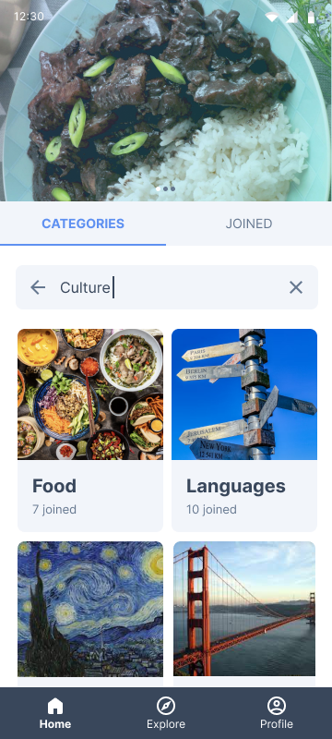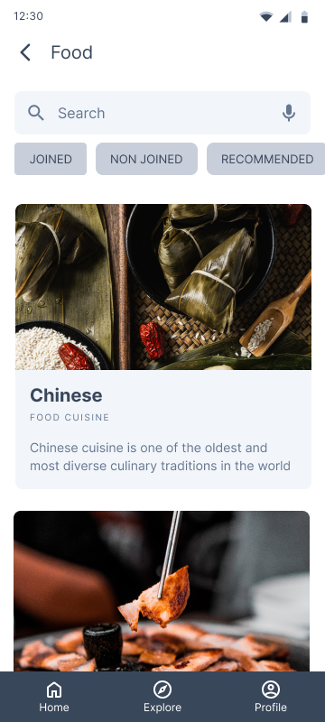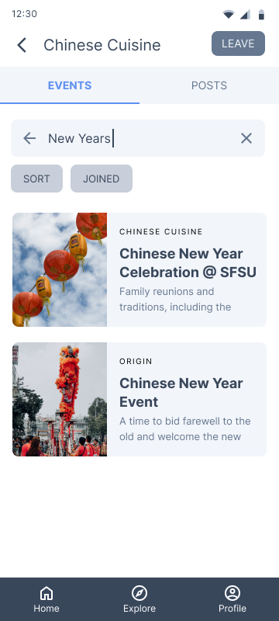

**2. Problem**: Inconsistent and repetitive naming across screens (i.e, tabs and search filters)

Heuristics: #4 Consistency and Standards, #8 A`esthetic and minimalist design

Severity: 2

Recommendations:

* More explicit wording to more accurately represent generalized naming conventions: “groups” over “categories”
* Make tabs consistent across screens



**3. Problem**: Inappropriate and inefficient labeling for the secondary call to action (CTA) buttons (i.e., search filters).

Heuristics: #4 Consistency and Standards

Severity: 3

Recommendations:

* Change and make more appropriate names for the search filters on the Explore Events page.

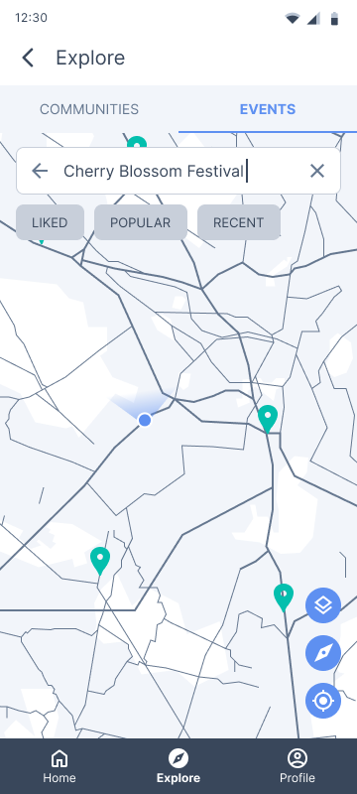

**4. Problem:** Users are unable to delete or edit posts and comments, and unjoin events

Heuristics: #3 User Control and Freedom, #5 Error Prevention

Severity: 4

Recommendations:

* Add corresponding functionality: edit, delete, and unjoin events buttons

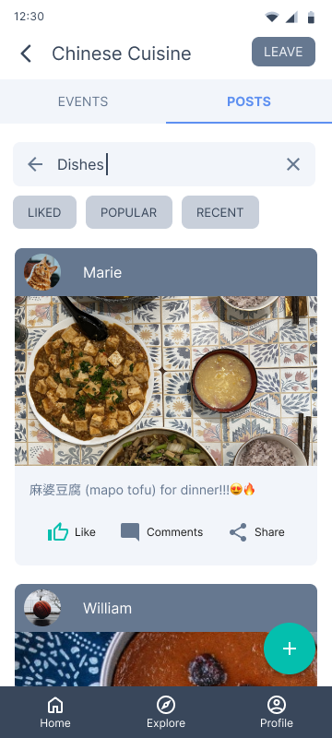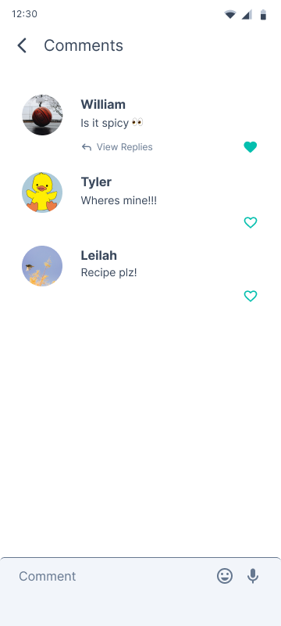

**5. Problem:** Users are unable to view their progress in the onboarding flow.

Heuristics: #1 Visibility of system status

Severity: 1

Recommendations:

* Add a progress bar to the top of the onboarding screens

**6. Problem:** Users are limited to choices in the Onboarding process (i.e., users don’t have the option to skip the who onboarding flow, users should be able to view more than three community options when being introduced to the app)

Heuristics: #3 User Control and Freedom, #7 Flexibility and Efficiency of Use

Severity: 2

Recommendations:

* Add the option to skip the whole onboarding process
* Populate more community suggestions in the onboarding process
* Add the ability to refresh populated community suggestions

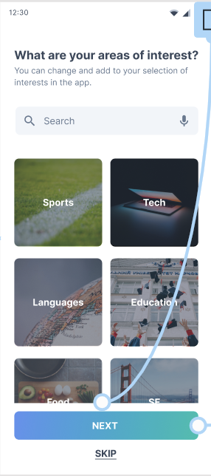

**7. Problem:** Users don’t have easy access to events they’ve joined and their posts.

Heuristics: #4 Consistency and standards, #3 User Control and Freedom, #7 Flexibility and Efficiency of Use

Severity: 3

Recommendations:

* Include a separate page for specific events that the user has joined and posts created by the user.
  + Consider placing this information under the profile page.

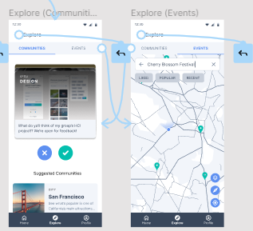

**8. Problem:** The current UI does not effectively communicate what the user needs to do on the explore & onboarding page for the app to populate suggested communities via the swipe feature.

Heuristics: #1 Visibility of system status, #2 Match between system and the real world, #10 Help and documentation

Severity: 1

Recommendations:

* Include a visual indicator that the post cards should be swiped
* Change the X and checkmark icons

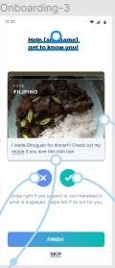

**9. Problem:** Include more flexibility and functionality to the already existing event features. Currently, the user can only join events, but users might want to have the ability to receive, save, and share events.

Heuristics: #7 Flexibility and Efficiency of Use

Severity: 2

Recommendations:

* Incorporate notification settings for individual events
* Add the option to save/bookmark events
* Add the option to share events with others



**10. Problem:** Back button to go to a previous screen can get stuck in a loop when creating a post since there is a delete button in the place of the back button when creating a post

Heuristics: #3 Match between system and the real world

Severity: 3

Recommendations:

* Adjust action flow from backtracking to the previous accessed screen to the expected page (e.g. instead of backtracking to creating a post from the post page, navigate towards the main community page)

